Decorator Function

A decorator is a function that adds extra behavior to another function without changing its original code.
One Golden Rule
- @decorator is executed when the function is defined
- function() is executed when the function is called
Example:
def my_decorator(func):
def wrapper():
print("Before function call")
func()
print("After function call")
return wrapper

@my_decorator
def say_hello():
print("Hello, Python!")
say_hello()
Diagram of this program:
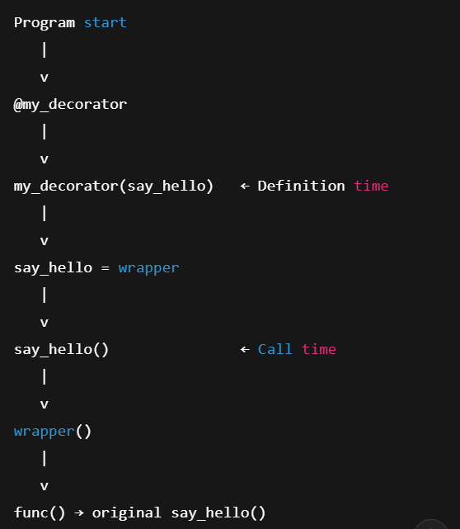
Basic questions:
- Create a decorator that prints “Function is called” before execution.
- Write a decorator that runs only once, even if the function is called many times.
- Create a decorator to count how many times a function is called.
Decorator with Arguments:
def my_decorator(func):
def wrapper(name):
print("Function started")
func(name)
print("Function ended")
return wrapper
@my_decorator
def greet(name):
print(f"Hello {name}")
greet("Hello")

decorator that works with functions having parameters
(*args and **kwargs are used so decorators can accept and pass any number of positional and keyword arguments.)
def my_decorator(func):
def wrapper(*args, **kwargs):
print("Function is called")
func(*args, **kwargs)
return wrapper
@my_decorator
def greet(name):
print("Hello", name)
greet("Rishith")

Questions (decorator with argument)
- Create a decorator that prints the arguments passed to a function.
- Write a decorator that checks if a number is positive before running the function.

- Write a decorator for login authentication.

